Exemplar Problem
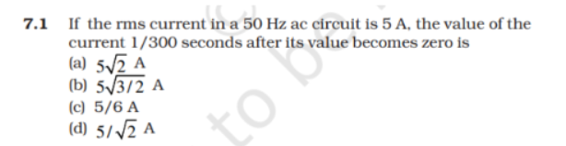

Solution
(b) calculate angular frequency, and use the sinusoidal function of AC current.

